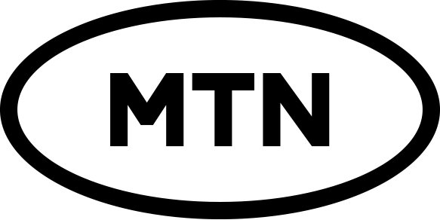

M-PESA DIVIDEND PAYMENT MANDATE

To: The Directors MTN Uganda Limited
Plot 69-71 Jinja Road
Kampala-Uganda

I……………………………………………………………………………………………Email-address………………………………………

of SCD number……………………………………………………………… being a shareholder of MTN Uganda Limited (“the company”) hereby instruct you to pay any dividends due to me via M-PESA through the Mobile Phone Number nominated herein.

Registered M-PESA Number.
+ | 2 | 5 | 4

Number

(*The number should be active and registered in your name)

I certify that the information provided above is true to the best of my knowledge and the instructions will remain valid unless otherwise instructed by me in writing.

By registering and accepting to receive my dividends via M-PESA I hereby agree to indemnify the company and / its Directors and Officers against any claims, losses, damages, costs and expenses which may, or be paid, incurred or sustained by the Company and / or its Directors / Officers by reason or in consequence of the company honoring my above instructions. Please note that this mandate supersedes any other payment instructions issued by me to you.

Signature………………………………………………………………… Date………………………………………………………

Terms and Conditions

  - No instructions will be honored where the particulars on the form differ from the particulars held by the Mobile Network Operator.
  - All transactions shall be denominated in Kenya Shillings.
  - You must be an individual shareholder and the phone number provided for mobile money dividend payment must be registered in your name in the Network system.

  - The details of how you can redeem your dividend once in the M-PESA system are comprised in the terms and conditions of usage of the M-PESA System.

